How to Build a Self-Watering Container
- Do you want to grow veggies in your classroom but, don’t think you or the students will remember to water it every day? Are you daunted by the fact that you would have to bring the plants home every holiday?
- Do you want to inspire students to grow their own food at home with cheap materials?
Build your own self-watering container in your classroom and begin growing veggies!
Tools
- Drill
- 1/4″ bit
- 3 1/2″ hole saw for metal and wood
- 1 1/4″ hole saw for metal and wood
Materials:
- 2 food grade 5 gallon containers -- 1 for planting container and 1 for reservoir container
- 1/2 deli container for wicking basket
- Pipe cut to the height of the container
Instructions On How to Make With 2 Containers With Pipe
- Use the 1/4″ drill bit to drill holes in the deli container.
- Attach the 3 1/2″ hole saw attachment to the drill. Drill a hole in the bottom of the container. I’ve found drilling in a counter-clockwise direction to work best.
- Attach the 1 1/4″ hole saw. Drill a hole close to the edge of the container.
- Reattach the 1/4″ drill bit and drill holes in the bottom of the planting container to allow for drainage.
- Put the wicking basket in the middle of the reservoir container.
- Place the planting container in the reservoir container aligning the wicking basket with the hole in the middle.
- There will be a little space between the wicking basket and the planting container. You can duct tape the basket to the bottom of the container, but it’s not necessary.
- Hold the containers up to the light. You should be able to see through the reservoir container where the planting container is. Using a 1/4″ drill bit, drill a hole 1/4″ in the reservoir container below where the planting container is.
- Put the pipe through the planting container to reach the reservoir container. The pipe will have some wiggle room and wont’ be snug. It’s ok. You can duct tape if you’d like.
- That’s it. You’re done!
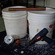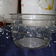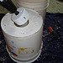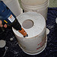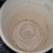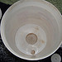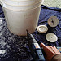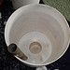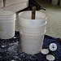
Make A Pizza Box Solar Oven!
