Wii in the classroom

Materials:
Wii Remote (new $39, used <$30)
Batteries
Bluetooth adaptor for PC (built into most computers built in the last 3 years)
Free software (See Resources)
DIY infra-red pen (<$5)

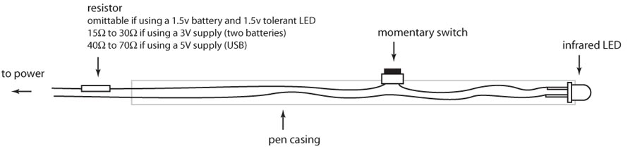
Optional Add-ons: Infra-red IR Array, Reflective tape, Projector

Activites:
1. Electronic whiteboard.
2. Motion tracking (the Wiimote can track 4 InfraRed light sources
3. Head tracking for virtual reality
4. You can use record and transfer tracking datas to other programs including software that will allow you to control sound using position. (Some of this software is super-expensive but there are cheaper tools online see: http://www.multimedialab.be/blog/?p=1016 for more info)
5. Use the accelerometer to collect data on motion for physics experiments: http://www.physorg.com/news104502773.html)

Windows resources:
For software, demos and support forums:

http://www.cs.cmu.edu/~johnny/projects/wii/

Mac OS X resources:
For software, demos and support forums:

http://www.uweschmidt.org/wiimote-whiteboard (ready-made software for interfacing)

http://sourceforge.net/projects/darwiin-remote/?abmode=1 (open-source communal project)

